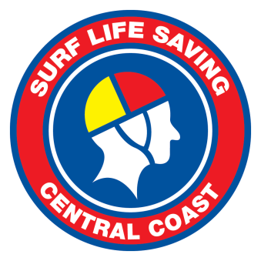

POSITION VACANT – MEMBER DEVELOPMENT OFFICER

Surf Life Saving Central Coast (SLSCC) is seeking an energetic, highly motivated and knowledgeable Member Development Officer to help us continue to build and develop a diverse range of requirements including events, youth activities and social media management.

SLSCC is the leading volunteer water safety organisation on the Central Coast and is an icon of the local community as well as being a vibrant and highly successful organisation with a clear direction for the future.

Reporting to the CEO, interested applicants should have demonstrated experience in the following key attributes for the role:

- A knowledge of Surf Life Saving procedures and practices
- Excellent communication (oral and written) and interpersonal skills
- An ability to work with volunteers
- Creative and a can do attitude
- Commitment to flexible work hours
- Great teamwork and relationship management skills
- Strong work ethic and Initiative
- Attention to detail

Applications outlining demonstrated experience in the above areas, complete with cover letter and resume, should be forwarded to the SLSCC Chief Executive Officer via email to ceo@slscc.com.au

For further information please contact Jon Harkness, Chief Executive Officer on
0417 999 137

