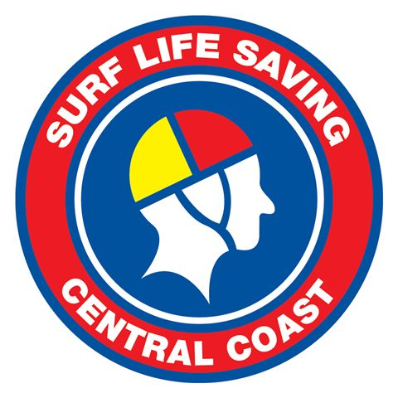

POSITION DESCRIPTION

MEMBER DEVELOPMENT - OFFICER

September 2022

The Member Development Officer role provides support to SLSCC members through events, youth activities and social media management.

Reporting directly to the Chief Executive Officer, this position maintains functional relationships with the following personnel:

  - Chief Executive Officer
  - Directors of Youth Development
  - Managers of Youth cohort
  - Club Executive Members and SLSCC Members
  - Other SLSCC Staff Members
  - Relevant staff members of SLSNSW and SLSA

The position will have the following duties, identified with performance indicators within the Surf Life Saving Central Coast Strategic Plan 2023/24 and annual Operations Plan.

(A) Member Development
- Coordinate and oversee an array of member development programs including but not limited to the Youth Leadership Programs
- Support clubs with the implementation of membership recruitment and retention initiatives
- Coordinate and attend Director of Administration Meetings
- Support the Director of Business Development, Director as requested.

(B) Social Media Management and Promotion
- Content development, campaigns and growth strategies for SLSCC social media
- Maintenance and content development of SLSCC website in conjunction with website host company
- Development of SLSCC monthly newsletter and stakeholder publications
- Assist the CEO with media releases and organising media activations
- Development of social media “tiles”
- Support the CEO with coordination and development of annual media advertisements
- Development of SLSCC Annual Report
- Produce and deliver the Branch Communications Plan
- Manage the Branch Calendar.

(C) Fundraising and Events
- Marketing, coordination and implementation of annualFundraising events
- Event management of the annual SLSCC Awards of Excellence, Sponsors Recognition Evening, Life Members Dinner and Raising of the Flags events.
- Assistance with other special events and fundraising activities as required.

(D) Club Support
- Plan, organise and implement the annual club administration conference or similar.
- Coordinate regular President Tea events with guest presenters on key areas of club development.

(E) General
- Liaison with relevant stakeholders and community groups
- Develop bi-monthly reports of activities for the various boards this role sits across
- Participate in the day to day activities of SLSCC as required by the CEO
- Proactively respond to all enquires and requests
- Exceptional customer service.

It is desirable that the Member Development Officer demonstrates the following attributes, qualifications and experience:

- A knowledge of Surf Life Saving procedures and practices
- Excellent communication (oral and written) and interpersonal skills
- An ability to work with volunteers
- Creative and a can do attitude
- Commitment to flexible work hours
- Great teamwork and relationship management skills
- Strong work ethic and Initiative
- Attention to detail

